User Guide

This guide helps you to configure the development environment of Eclipse ,create a connection with NI ELVIS III. You can debug or run the project on the ELVIS III with Eclipse.

Set up the Software Environment

1. To use Eclipse ,you need to first Install Java SE JDK 32-bit(x86) Java SE 6 or greater , which you can download at [*http://www.oracle.com/technetwork/java/javase/downloads/index.html*](http://www.oracle.com/technetwork/java/javase/downloads/index.html)*.*
2. Install C/C++ Development Tools for NI Linux Real-Time, Eclipse Edition , which you can download at [*http://www.ni.com/download/labview-real-time-module-2017/6731/en/*](http://www.ni.com/download/labview-real-time-module-2017/6731/en/%20)

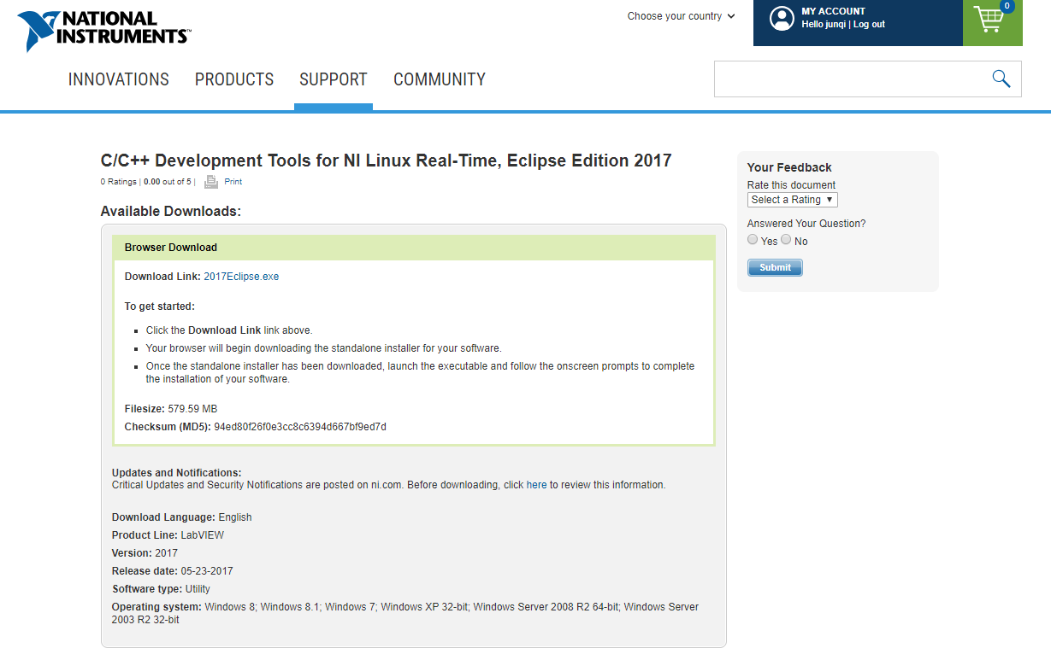

1. Add the compiler path , library path to the system environment variables

a. In the Windows Control Panel, select **System and Security » System** » **Advanced system settings** to display the **System Properties** dialog box.

b. Click **Environment Variables** to display the **Environment Variables** dialog box.

c. Select **PATH** in the **User variables** group box and click **Edit**. If **PATH** does not exist, click **New** to create one.

d. Append the compiler path to **Variable value**. Delimit paths with semicolons.

*C:\build\17.0\arm\sysroots\i686-nilrtsdk-mingw32\usr\bin\arm-nilrt-linux-gnueabi*

e. Click **OK** to close the dialog boxes and save changes.

f. Click **New** in the **User variable** group box to display the New User Variable dialog box.

g. In the Variable name, enter **LIB_PATH**.

h. In the Variable value box, enter: *C:\build\17.0\arm\sysroots\cortexa9-vfpv3-nilrt-linux-gnueabi*

i. Click **OK** to close the dialog boxes and save changes.

f. Click **New** in the **User variable** group box to display the New User Variable dialog box.

g. In the Variable name, enter **C_INCLUDE_PATH**.

h. In the Variable value box, enter: *%LIB_PATH%/usr/include*

i. Click **OK** to close the dialog boxes and save changes.

You have successfully configured the development environment.

**Note** The paths are customized for the 2017 version of Eclipse. If you use other versions of Eclipse, update the value to use the cross-compilers directory of Eclipse.

Start Eclipse

1. Run Eclipse from the location where it is installed.
2. The Select a Workspace dialog shows. Click **OK**.
3. If the Welcome screen shows, click the Arrow to go to the Eclipse Workbench (C/C++ Editor)

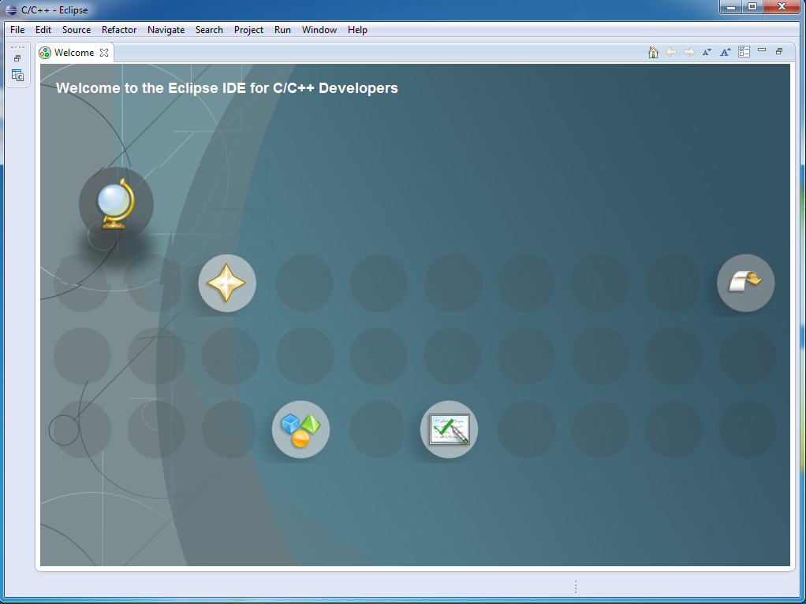

Create the connection with ELVIS III

1. Click **Window > Open Perspective > Other...**. Select **Remote System Explorer**. Click **OK**.

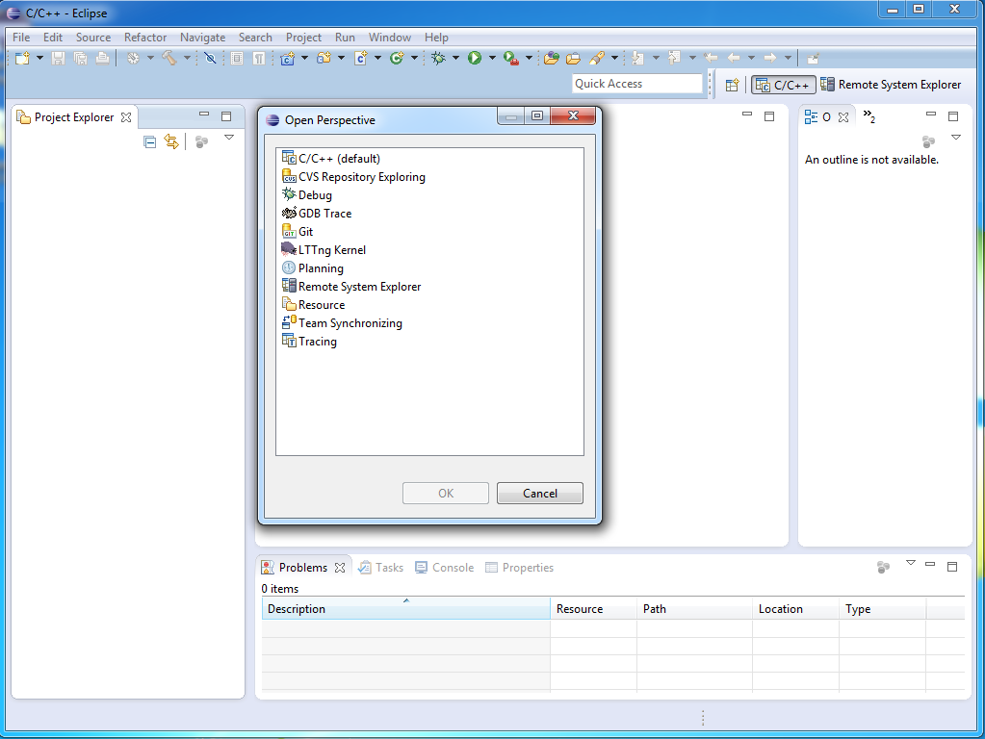

1. In the Remote Systems pane's toolbar, click the **Define a new connection to a remote system**. The New Connection dialog shows.

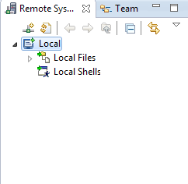

1. On the Select Remote System Type step, select **Linux**. Click **Next**.
2. On the Remote Linux System Configure step, input the **Host name**: the wireless IP address. Click **Next**.

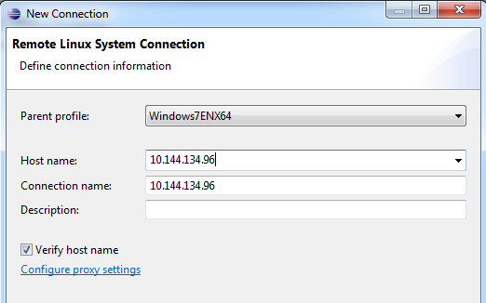

1. On the Files step, select **ssh.files**. Click **Next**.

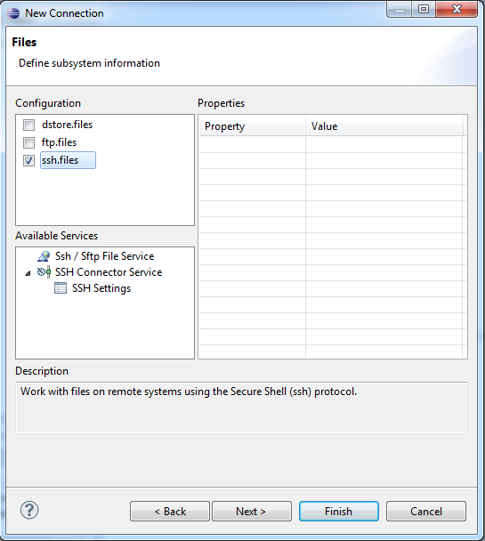

1. On the Processes step, select **processes.shell.linux**. Click **Next**.
2. On the Shells step, select **ssh.shells**. Click **Next**.
3. On the SSH Terminals step, click **Finish**. The remote system shoes in the Remote Systems pane.
4. In the Remote Systems pane, right click the target, then click **Connect**. The Enter Password dialog shows.

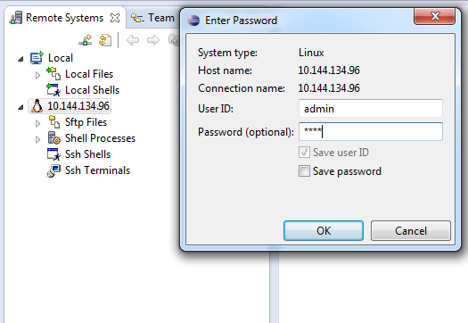

1. Input the user ID and the password of the ELVIS III. Click **OK**.
2. The Info dialog shows. Click **OK** .You have successfully connected to the ELVIS III.

Create the Eclipse C Project

Use C examples to try how to run a project on ELVIS III with Eclipse.

1. Click **Window > Open Perspective > Other...**. Select **C/C++ (default)**. Click OK.
2. Click **File > Import...** The Import dialog shows.
3. Select General  **> Existing Projects into Workspace**. Click **Next >**

**Note** Before import , you need to download the C support archive file .You can download C support archive file from……

1. Select **Select archive file**. Click **Browse...** and select the latest build C support archive file.
2. Check C Support file and the example to import. Click **Finish**.

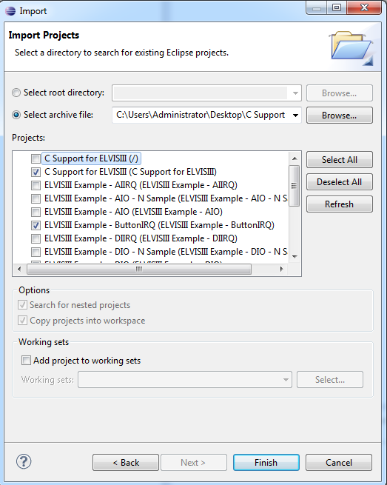

Install Bitfiles

Bitfiles contain information about the interfaces and registers of the hardware .Before using ELVIS III ,you need to install bitfiles in ELVIS III. You can download bitfiles from …

1. Click **Window > Open Perspective > Other...**. Select **Remote System Explorer**. Click **OK**.
2. In the Remote Systems pane's toolbar, expand **Sftp Files > root**. Right-click **Root**, and click **New > Folder**.The New Folder dialog shows.

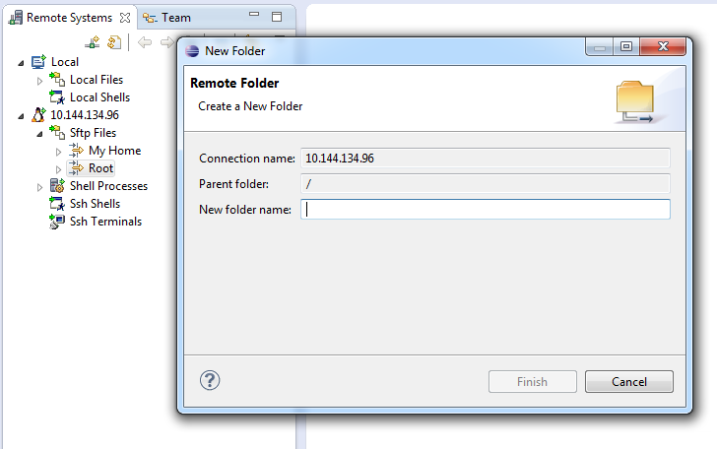

1. Input the folder name /var/local/natinst/bitfiles. Click **OK**.  
   Ignore any error if the folder already exists.
2. In the Remote Systems pane, right-click the newly created folder, click **Export From Project...**. The Export dialog shows.
3. Expand the project, and export the file like *NiFpga_ELVISIIIv10FPGA.lvbitx* (depending on the hardware you are using). Then click **Finish**.

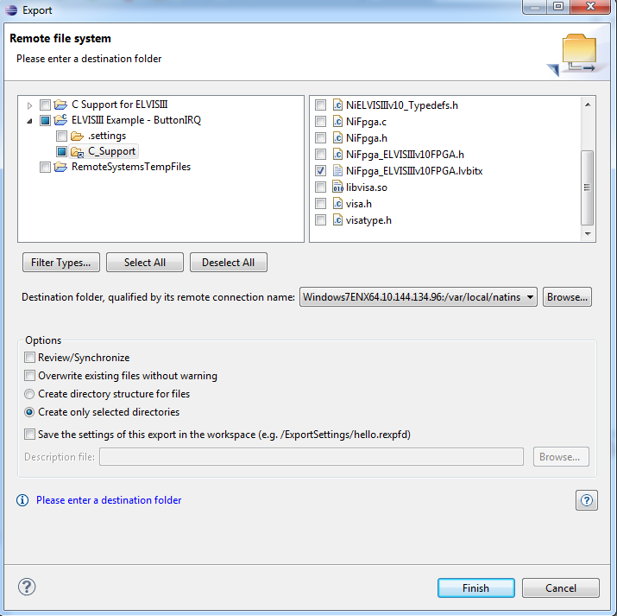

Build and Install Executable

1. Click **Window > Open Perspective > Other...**. Select **C/C++ (default)**. Click **OK**.
2. In the Project Explorer pane, select the project. Click **Project > Build Project**. Wait until the project finishes building.

**NOTE:** if you do not have the path to the toolchain added to the PATH environment variable, your build will fail.

1. In the Project Explorer pane, select the project. Click **Run > Run Configurations .**Right-click **C/C++ Remote Application** ,Click **New .**Run Configurations pane of the project shows .

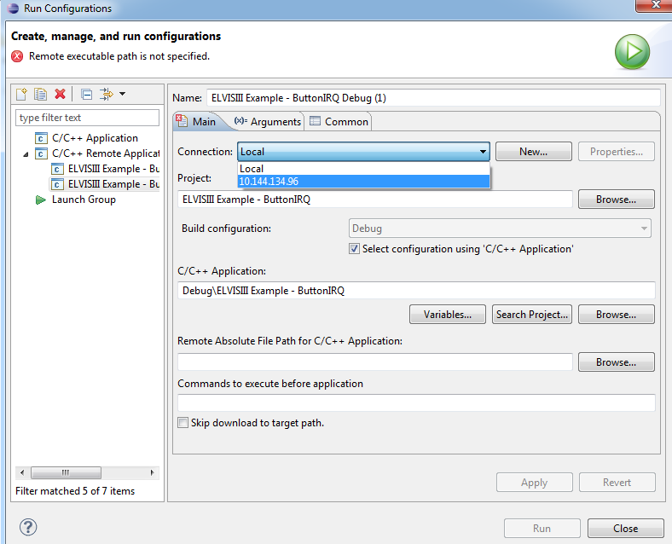

1. Click **Connection** and select the target IP address to connect with the ELVIS III.
2. In right hand pane beneath *Remote Absolute File Path for C/C++ Application*, click **Browse** to create a new folder for this project in ELVIS III .Select Remote C/C++ Application File dialog shows.
3. Right-click **My Home** .Click **New** .Click **Folder** . Input New folder name .Click **Finish** .
4. Select newly created folder .Click **OK** .Add the project name to the Remote Absolute File Path .Add */<project name> to /home/admin/<new folder name>.*Click **Apply** .

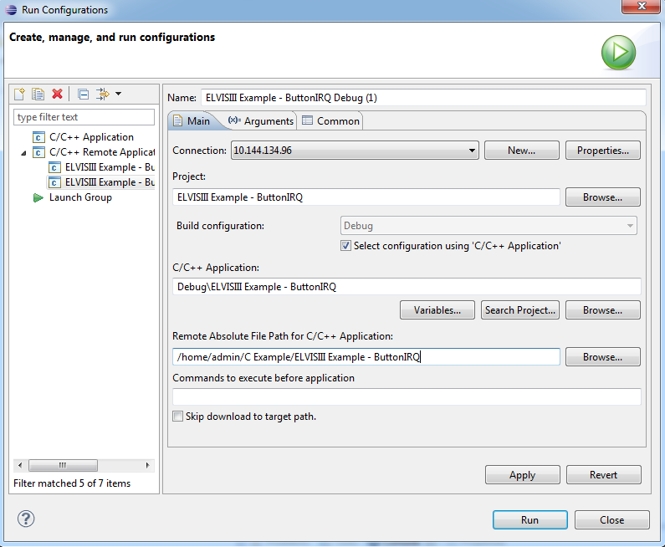

Project name

New folder name

1. Click **Run**